Documet for facts related to PostgreSQL
Prepared by : Garun Mishra
Date : 2017-05-012

=>What are postgreSQL:
-> PostgreSQL is a powerful, opensource object relational darabase system. Its a proven architecture that have earned it a strong reputation for reliability, data integrity, and correctness.
-> It runs on all major operating systems including Linux, Unix and windows.
-> It is a fully ACID compliants, has full support for foreign key, joins, views, triggers, and store procedures(in multiple language).
-> It includes most SQL:2008 data types, including INTEGER, NUMERIC, BOOLEAN, CHAR, VARCHAR, DATE, INTERVAL and TIMESTAMP.
-> It also supports storage of binary large objects, including pictures, sound and videos.
-> It has native programming interfaces for C/C++, Java, .NET, Python, Ruby, Tcl, ODBC, among others.
-> An enterprise class database, PostgreSQL boast sophisticated features such as Multi-Version Concurrency Control(MVCC), point in time recovery, tablespaces, asynchronous replication, nested transaction(save point), online hot backup, a sophisticated query planner/optimizer, and write ahead logging for fault tollerence.
->It support international character sets, multibyte charatcer encodings, Unicode, and it is locale-aware for sorting, case-sensitivity, and formatting.
-> It is highly scalable both in the sheer quantity of data it can manage and in the number of concurrent users it can manageand in the number of concurrent users it can accoumodate.
-> There are active PostgreSQL system in production environments that manage in excess of 4 terabytes of datat.

=> Difference between PostgreSQL and MySQL:

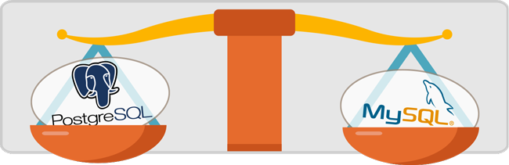
There are radical difference between PostgreSQL and MySQL:

PostgreSQL | MySQL
PostgreSQL is developed by the PostgreSQL Global Development Group, a diverse group of multiple companies and individual contributors.  It’s free and open-source software. PostgreSQL is released under the PostgreSQL license, a liberal Open Source license, similar to the BSD or MIT licenses. | The MySQL development project has made its source code available under the terms of the GNU General Public License, as well as a variety of proprietary agreements.  It’s now owned by Oracle Corporation and offers several paid editions for proprietary use.

